Coffee shop

Tech stack we can use: Java 8, PostgresSql, Kafka, Redis, Nginx Proxy, Spring Boot, Spring Security, KeyCloak, Elastisearch, Kibana, LiquiBase,Docker…
Architecture: microservice architecture
Model: Scrum/Agile
CUSTOMER APP

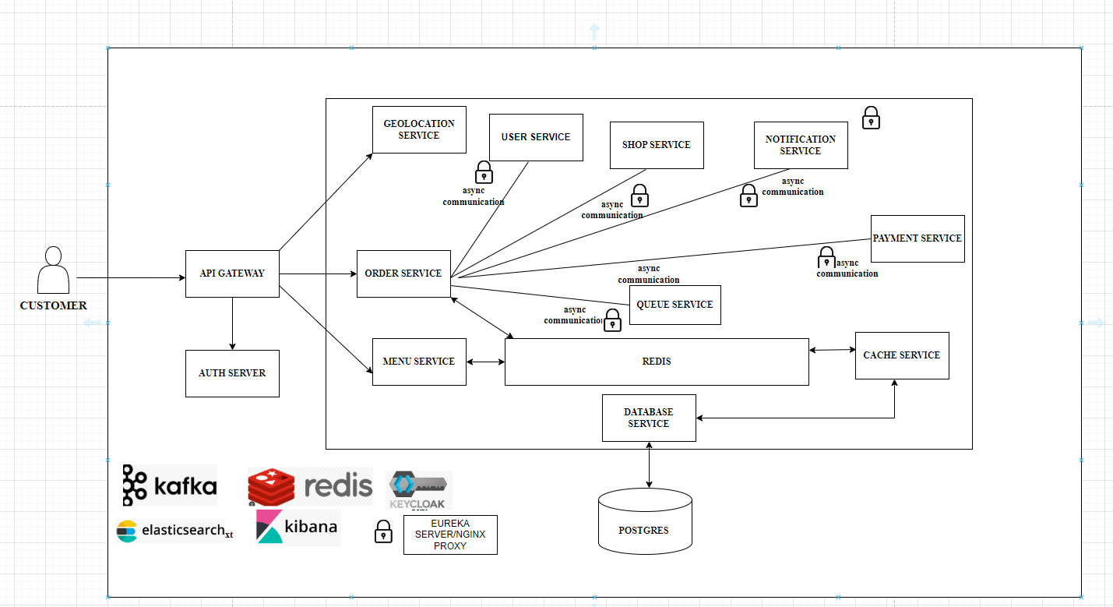

COFFEE SHOP APP(FOR SHOP OWNER)
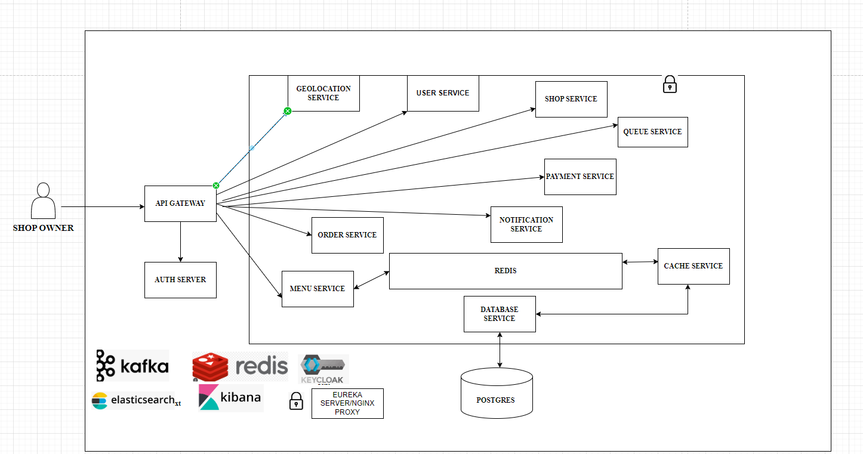
The services:
-Menu Management Service: Handles the creation, updating, and deletion of menu items for each coffee shop. It also manages the pricing and availability of items based on shop-specific menus.
-Geolocation Service: Enables customers to find the nearest coffee shops based on their location. This service might use GPS data or location-based APIs to provide accurate results.
- Order Management Service: Manages the creation, processing, and tracking of customer orders. It includes functionalities like order placement, updating order status, calculating waiting times, and notifying customers when their order is ready.
-Queue Management Service: Responsible for managing the queues at coffee shops. It handles customer check-in, position tracking, and serving customers in the correct order. Depending on shop-specific configurations, it may support multiple queues in some shops
- Shop Service: This service allows shop owners or administrators to configure and customize their individual coffee shop's settings, including location details, menu, queue management, and operating hours.
- Notification Service: Sends real-time notifications to customers regarding their order status changes (e.g., "Your order is ready") and important updates. It can also notify coffee shop staff about new orders and queue changes.
-Payment Gateway Service: If the app allows customers to make payments within the app, you would need a payment gateway service to securely process payments.
-Database Service: This is not a user-facing service but a critical component of the backend. It stores all data related to shops, menus, orders, customers, queues, and more.

Data design

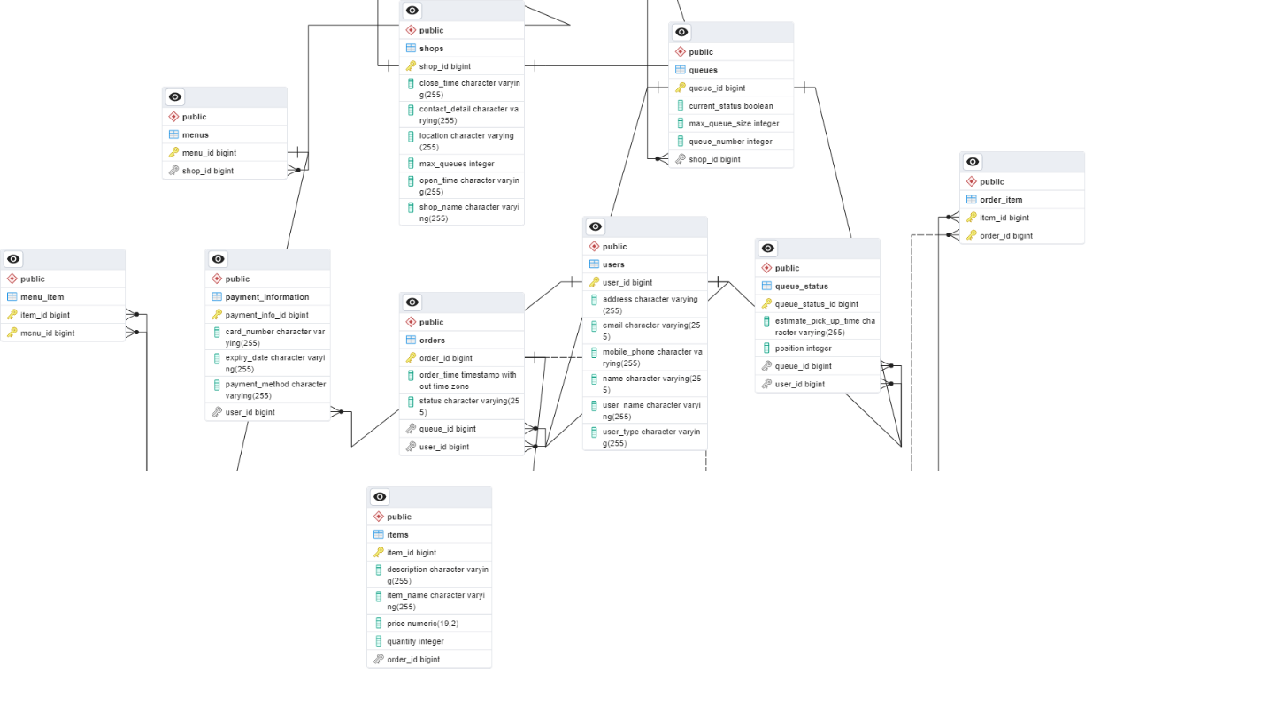
Estimate to build out the solution
1. Requirements Gathering and Analysis:

Time Estimate: 2-4 weeks
Activities:
Meeting with stakeholders to gather detailed requirements.
Analyzing and refining requirements.
Defining the scope of work.
Creating user stories and use cases.
2. Database Design and Setup:

Time Estimate: 2-3 weeks
Activities:
Designing the database schema.
Setting up the database management system.
Creating tables, relationships, and constraints.
Populating initial data (e.g., sample menu items).
3. Backend Development (API, Server, Business Logic):

Time Estimate: 8-12 weeks
Activities:
Developing APIs for customer and admin functionalities.
Implementing business logic for order management, queue handling, and user authentication.
Implementing shop configuration features.
Implementing serving history tracking.
4. Frontend Development (Customer and Admin Apps):

Time Estimate: 10-14 weeks
Activities:
Developing the customer app for Android and iOS.
Developing the admin app for Android.
Implementing user registration and login.
Creating user interfaces for ordering, queue management, and shop configuration.
Integrating with backend APIs.
5. Testing and Quality Assurance:

Time Estimate: 4-6 weeks
Activities:
Functional testing of all features.
Performance testing.
Security testing.
Usability testing.
Bug fixing and issue resolution.
6. Deployment and Launch:

Time Estimate: 2-3 weeks
Activities:
Preparing for deployment to app stores (Google Play Store and Apple App Store).
Deploying backend services to a production environment.
Final user acceptance testing.
Marketing and promotional activities.
7. Post-Launch Maintenance and Support:

Ongoing
Activities:
Monitoring and maintaining the app.
Regular updates and bug fixes.
Responding to user feedback and issues.
Scaling and optimizing the system as user base grows.

